Information on the AXIS M1011-W Camera (can be fitted under the Pelican)
Type: AXIS M1011-W
- Functional and smart design
- Progressive scan
- Multiple H.264, Motion JPEG and MPEG-4 video streams
- Wireless connectivity
- Easy and flexible installation

Small and functional camera design
AXIS M1011-W Network Camera is perfectly suited for securing small businesses, boutiques, restaurants, hotels or residences. The camera offers both wireless (IEEE 802.11g) and wired connection to the network for flexible installation. It offers superior video quality in its class at 30 frames per second in VGA resolution.

High-performance compression and streaming capabilities
AXIS M1011-W provides multiple, individually configurable video streams in H.264 as well as Motion JPEG and MPEG-4 Part 2. Full frame rate and resolution is provided in either compression. The H.264 compression enables optimization for bandwidth and storage efficiency by significantly reducing the bit rate.
Settings on May 8 2012:
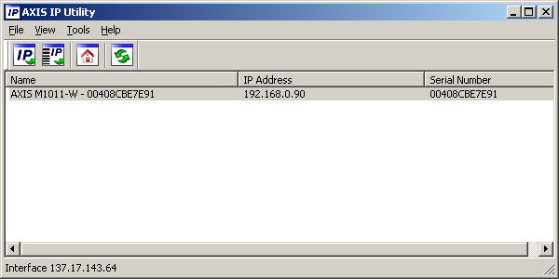
Administrator Panel
User name: root
Password: ssa

